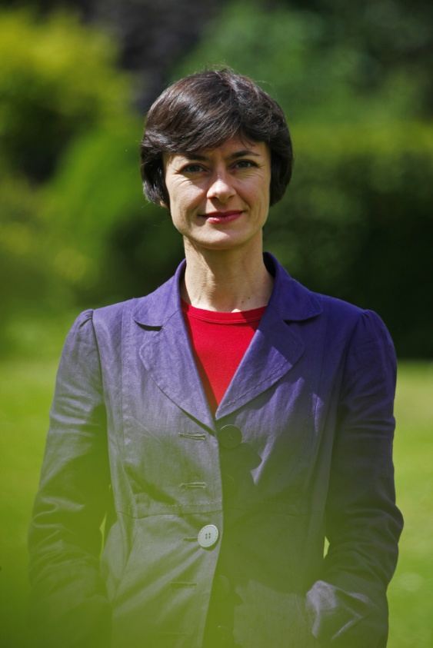

Fellow

of the Oxford Leadership Academy, UK

# Roxane Loiseaux

**Roxane is a certified coach (CPCC, PCC) and a trainer in coaching and leadership. She is committed to supporting individuals in their personal growth through self-awareness and conscious response-ability, hence creating a leadership culture from the inside out. She deeply cares about people being able to re-connect with their whole self and therefore creating a more humane and fulfilling working environment.**

As a trainer, Roxane leads coaching training courses at an international level as a Front of Room Leader for The Coaches Training Institute (CTI) and she is involved in the CTI Coaching Certification Programme as a supervisor, examiner and in the near future as a supervision quality reviewer. She delivers and facilitates leadership programmes for the Oxford Leadership Academy (Self-Managing Leadership™, Leading High Performing Teams), in the context of open courses and in house (with companies such as Vedior, Telefónica, Ferrovial, AkzoNobel, BASF, Metro). Roxane also designs and delivers Train the Trainers programmes for new OLA faculty.

As a coach, Roxane is a member of the International Coach Federation, and works with senior executives in multinational corporations and directors of small companies.

She is an authorised facilitator of The Leadership Circle Profile™ and the Team Diagnostic™ (Team Coaching International). Roxane’s portfolio includes body work, as a Nia™ practitioner, and spiritual work, through meditation and the study of the Enneagram.

Roxane has lived in the UK since 1996, and has also spent more than two years living in Spain. French being her mother tongue, she speaks English and Castellan (Spanish) fluently, and some German.

**Professional background:**

Secondary education teacher (languages)

Tour coordinator in a tour operator, including sales and marketing

Project and client relationship manager for a consultant company.

**Training and education:**

PCC – ICF

The Act of Leadership - eKCosystem.

ORSC (Organisation and Relationship Systems Coaching) –The Center for Right Relationship.

Leadership Programme – CTI

SML™ programme – OLA

CPCC – Augere Foundation/ CTI

Nia™ White Belt and Green Belt

PGCE (foreign languages) – Open University, UK

Master degree in Philosophy – University of Amiens

Bachelor's degrees (Philosophy and English Language and Culture) – University of Amiens and Keele University, UK,

DEUG certificates in Philosophy and Sociology – University of Amiens

Ecole Supérieure de Commerce of Amiens